IMPORTANT NOTES:
- Before making updates, create a backup of the pages being updated.
- Only use relevant existing images wherever they are used. Do not add stock images without approval

UPDATES TO BE MADE

- Update the homepage as per this screenshot
- Update https://skyflex.au/louvred-pergolas-sydney/ as per this screenshot
- Update https://skyflex.au/product/delta-pro-retractable-roof/, https://skyflex.au/product/delta-commercial-folding-arm/, https://skyflex.au/product/skyflex-4k-android-smart-outdoor-tv/, https://skyflex.au/product/skyflex-bbq-pods/ as per this screenshot
NOTE:
On a few product pages, you will find this comment which has to be followed as part of design work.
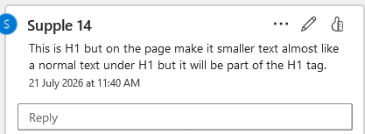
- Create a new page https://skyflex.au/smart-toilets/ which is a collection page as per this screenshot
- Add this text under: main navigation → INDOOR PRODUCTS
“View All Smart Toilets” and link it to https://skyflex.au/smart-toilets/

